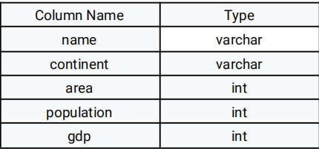

**51.)** name is the primary key column for this table.

Each row of this table gives information about the name of a country, the continent to which it

belongs, its area, the population, and its GDP value.

A country is big if:

● it has an area of at least three million (i.e., 3000000 km2), or

● it has a population of at least twenty-five million (i.e., 25000000).

Write an SQL query to report the name, population, and area of the big countries.

Return the result table in any order.

The query result format is in the following example.

Input:

World table:

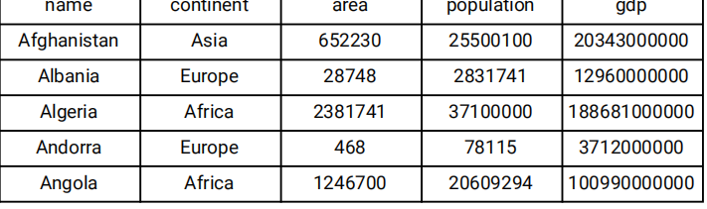

**Solution:**

create DATABASE Ineuron;

use Ineuron;

Create TABLE World (

    Name varchar(255),

    continent varchar(255),

    area int,

    Population int,

    gdp INT,

    PRIMARY KEY (Name)

);

ALTER table World MODIFY COLUMN  gdp BIGINT;

INSERT INTO World VALUES ('Afghanistan','Asia',652230,25500100,20343000000);

INSERT INTO World VALUES ('Albania','Europe',28748,2831741,1296000000),('Algeria','Africa',2381741,37100000,188681000000),('Andorra','Europe',468,78115,3712000000),('Angola','Africa',1246700,20609294,100990000);

select * from World;

select name,population,area from World where area >=3000000 or population >= 25000000;

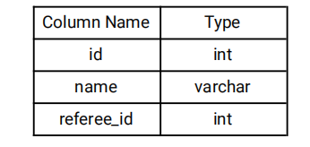

**52.)** id is the primary key column for this table.

Each row of this table indicates the id of a customer, their name, and the id of the customer who

referred them.

Write an SQL query to report the names of the customer that are not referred by the customer with id = 2.

Return the result table in any order.

The query result format is in the following example.

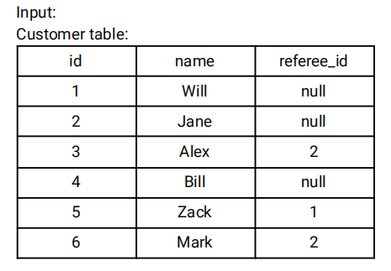

**Solution:**

create table Customer (

    id int,

    name varchar(50),

    refree_id INT

);

Insert INTO Customer VALUES (1,'Will',null),(2,'Jane',null),(3,'Alex',2),(4,'Bill',null),(5,'Zack',1),(6,'Mark',2);

select * from Customer;

select name from Customer where id<>2 OR id IS NULL;

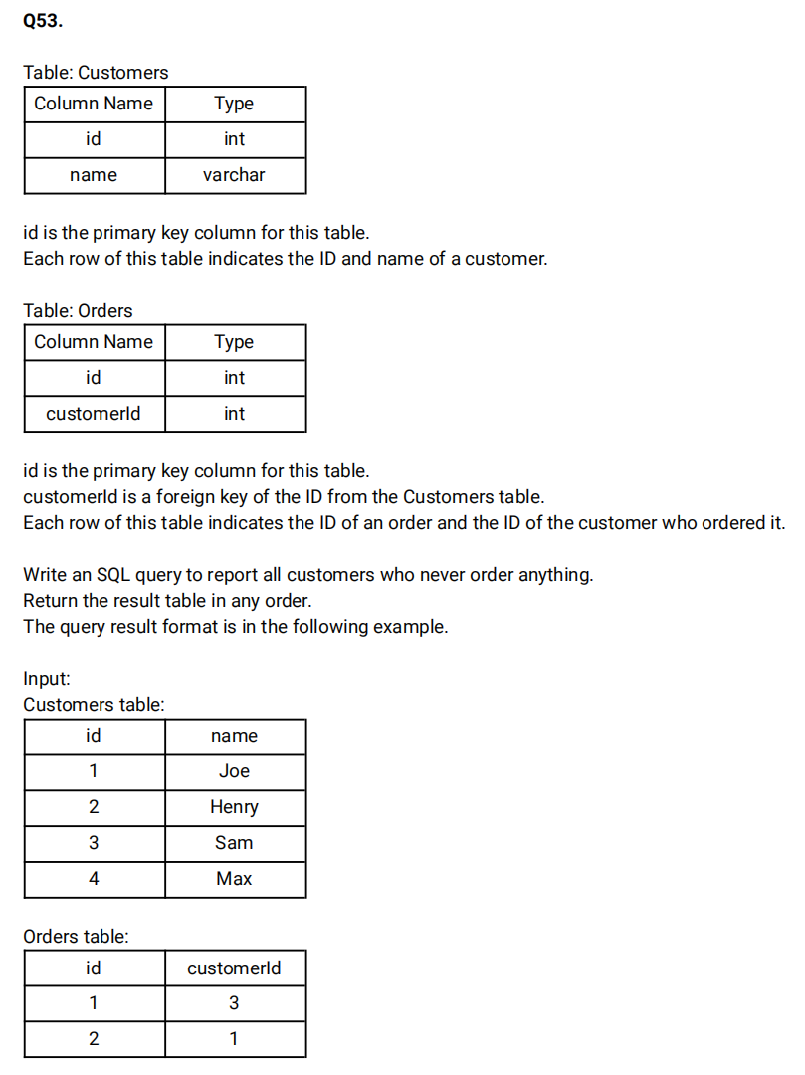

**Solution:**

create Table Customers (

    id int,

    name VARCHAR(100),

    PRIMARY KEY(id)

);

create table orders (

    id int PRIMARY KEY,

    customer_id INT,

    FOREIGN KEY(customer_id) REFERENCES Customers(id)

);

INSERT INTO Customers VALUES (1,'Joe'),(2,'Henry'),(3,'Sam'),(4,'Max');

INSERT INTO orders VALUES(1,3),(2,1);

 select distinct name from Customers C join orders o where C.id NOT IN(Select customer_id from orders) ;

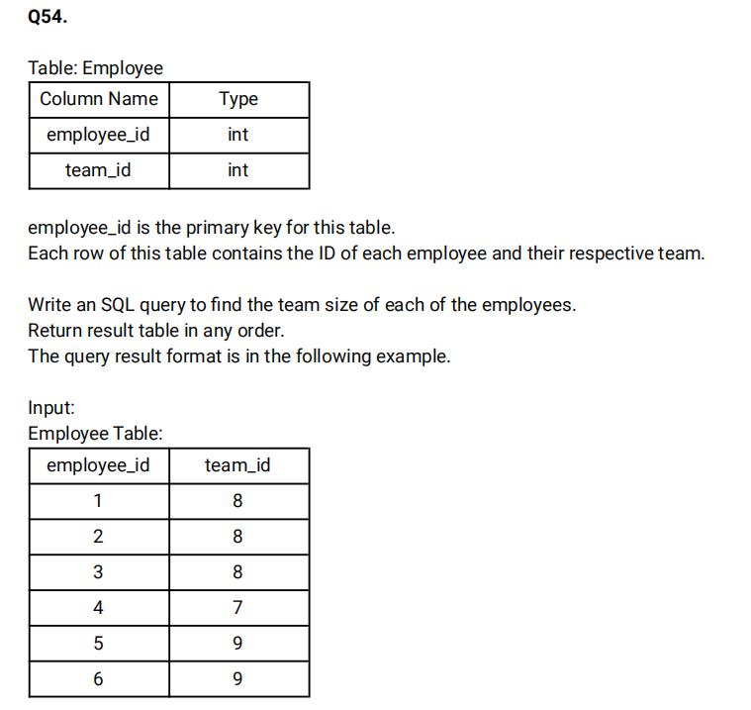

create table employee (

    employee_id INT PRIMARY KEY,

    team_id INT

 );

 INSERT INTO employee VALUES (1,8),(2,8),(3,8),(4,7),(5,9),(6,9);

 select * from employee;

 select employee_id, COUNT(team_id) OVER(PARTITION BY team_id) as team_size from employee order by employee_id;

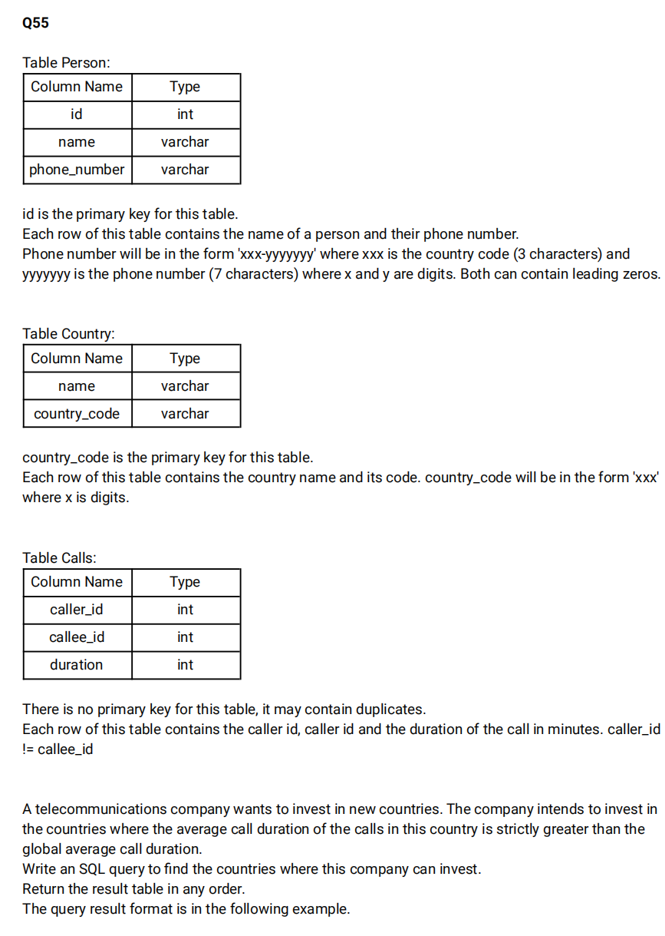

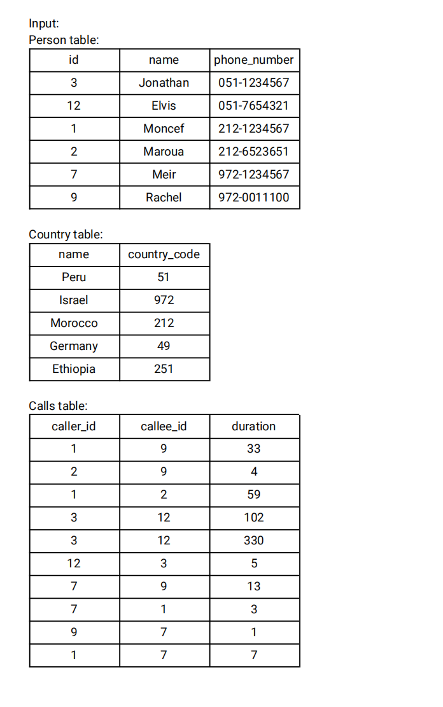

create table person(

    id INT,

    name VARCHAR(255),

    phone_number VARCHAR(255)

 );

 create table country(

    name VARCHAR(50),

    country_code VARCHAR(10) PRIMARY KEY

 );

 ALTER Table person ADD constraint PRIMARY KEY(id);

 create table calls(

    caller_id INT,

    callee_id INT,

    duration INT

 );

 INSERT INTO person VALUES(3,'Jonathan','051-1234567'),(12,'Elvis','051-7654321'),(1,'Moncef','212-1234567'),(2,'Maroua','212-6523651'),(7,'Meir','972-1234567'),(9,'Rachel','972-0011100');

 INSERT INTO country VALUES ('Peru','051'),('Israel','972'),('Morocco','212'),('Germany','49'),('Ethiopia','251');

 INSERT INTO calls VALUES (1,9,33),(2,9,4),(1,2,59),(3,12,102),(3,12,330),(12,3,5),(7,9,13),(7,1,3),(9,7,1),(1,7,7);

 select c.name as country from person p join country c on SUBSTRING(phone_number,1,3)=c.country_code join calls ca on p.id IN (ca.caller_id,ca.callee_id) group by c.name HAVING AVG(duration)>(select AVG(duration) from calls);

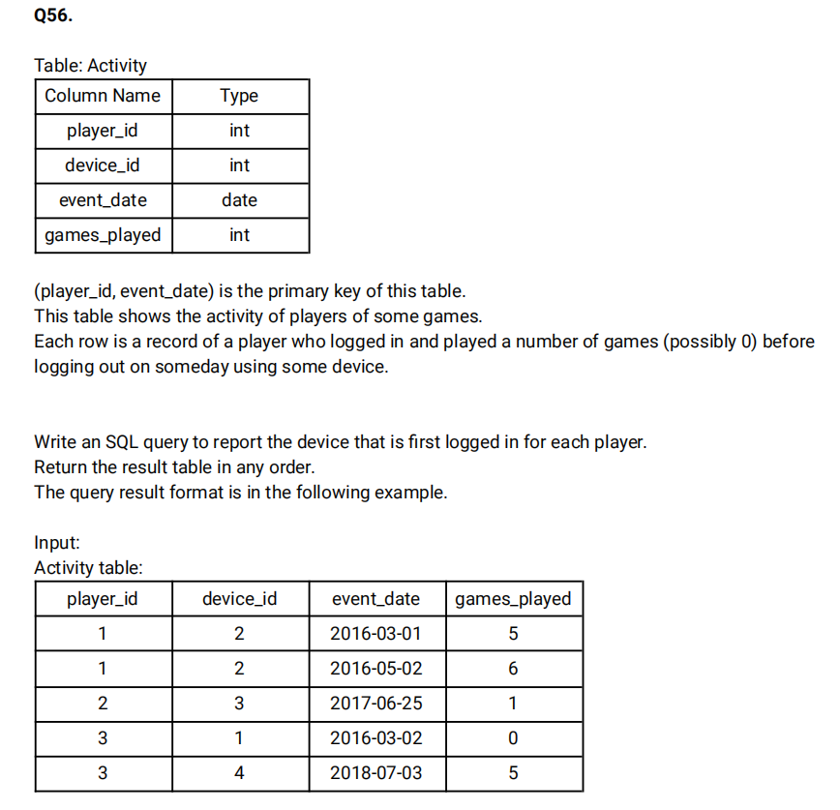

create table Activity (

    player_id INT,

    device_id INT,

    event_date DATE,

    games_played INT,

    PRIMARY KEY(player_id,event_date)

 );

 INSERT INTO Activity VALUES(1,2,'2016-03-01',5),(1,2,'2016-05-02',6),(2,3,'2017-06-25',1),(3,1,'2016-03-02',0),(3,4,'2018-07-03',5);

select player_id,device_id FROM (select player_id,device_id, DENSE_RANK() OVER (partition by player_id order by event_date ASC) as cnt from Activity)temp WHERE cnt=1;

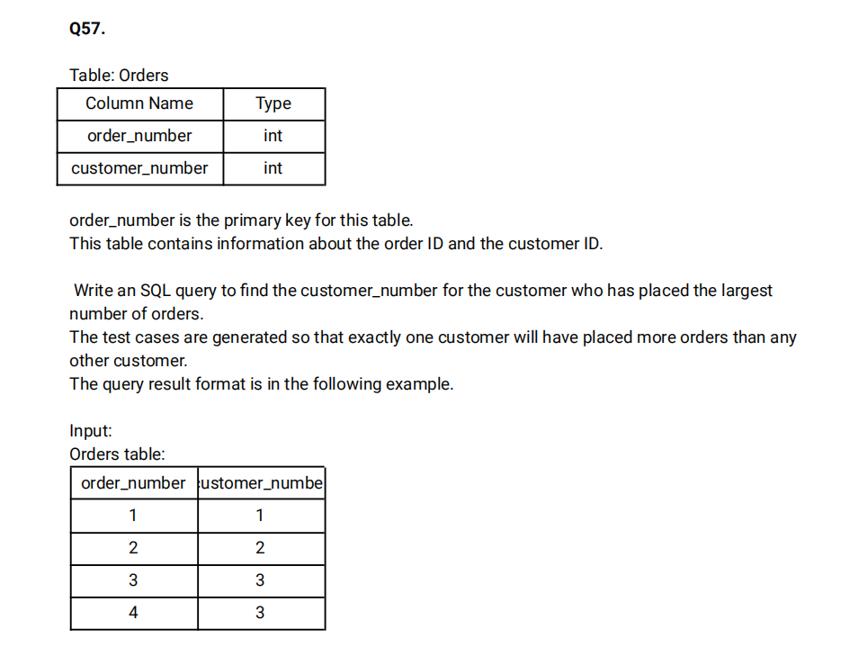

create table Orders(

    order_number INT PRIMARY KEY,

    customer_number INT

 );

 INSERT INTO Orders VALUES (1,1),(2,2),(3,3),(4,3);

 select customer_number from (select customer_number,count(order_number) as cnt from Orders group by customer_number order by cnt desc limit 1)t;

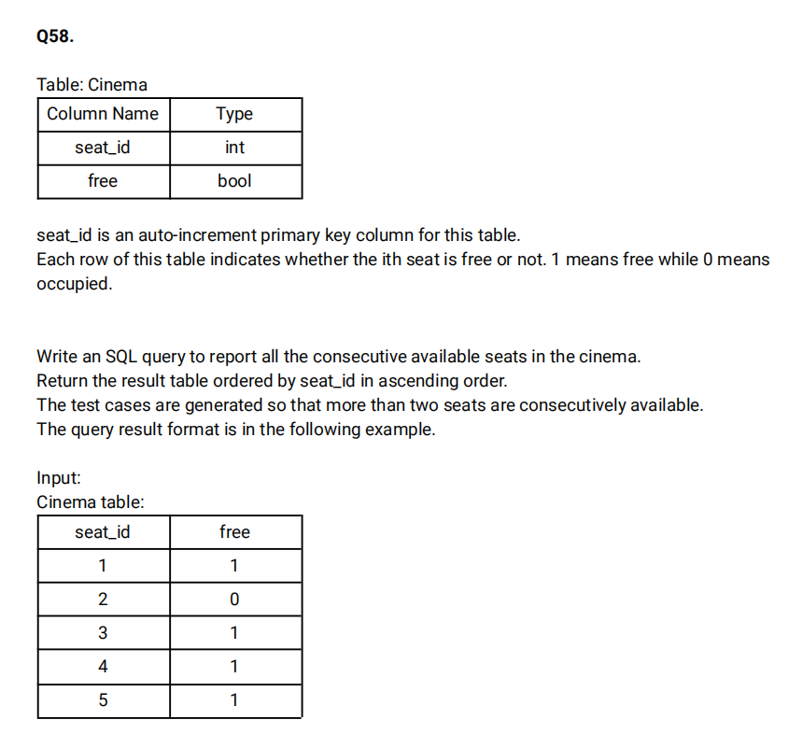

create table cinema (

   seat_id INT PRIMARY KEY AUTO_INCREMENT,

   free BOOLEAN

 );

 INSERT INTO cinema (free) VALUES (1),(0),(1),(1),(1);

 select * from cinema;

 select  s1.seat_id from cinema s1 join cinema s2 on s1.seat_id=s2.seat_id+1 and s1.free <> 0;

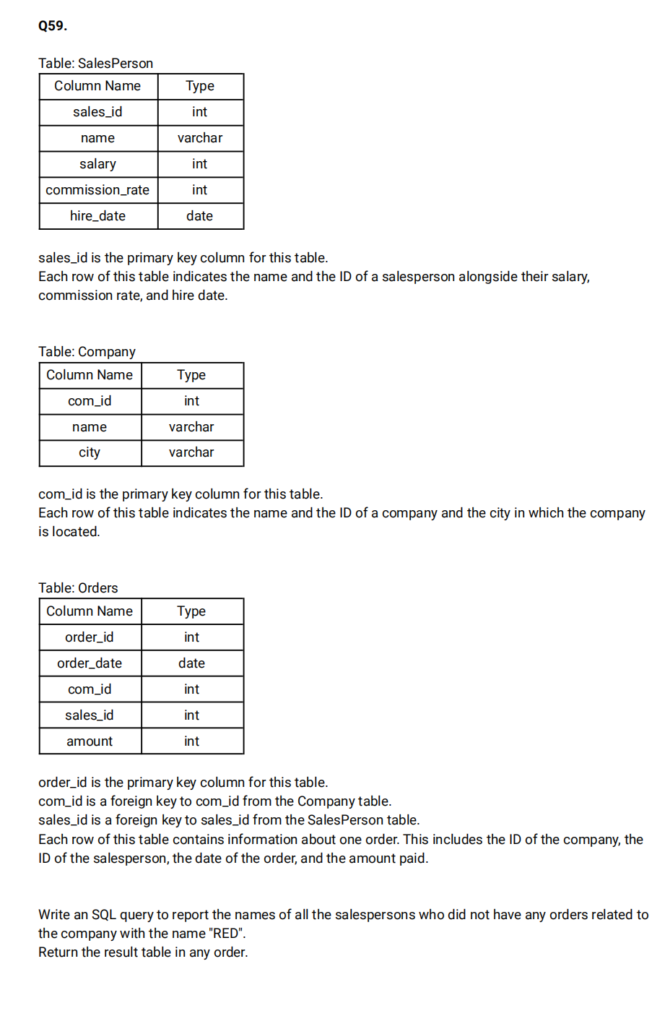

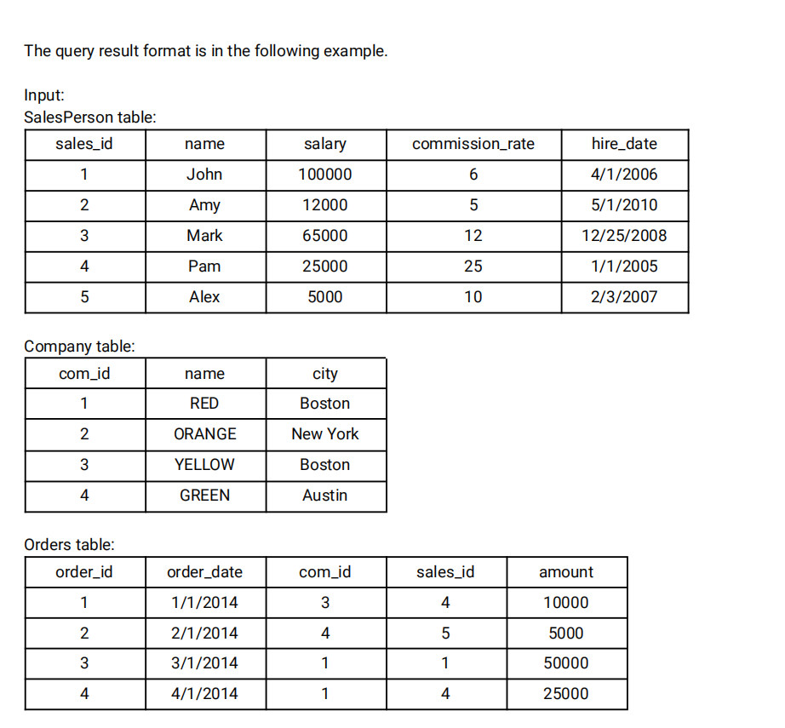

create table salesperson (

   sales_id INT PRIMARY KEY,

   name VARCHAR(50),

   salary INT,

   commission_rate INT,

   hire_date DATE

 );

 create Table company (

   com_id INT PRIMARY KEY,

   name VARCHAR(50),

   city VARCHAR(50)

 );

 create table Orders (

   order_id INT PRIMARY KEY,

   order_date DATE,

   com_id INT,

   sales_id INT,

   amount INT,

   FOREIGN KEY(com_id) REFERENCES company(com_id),

   FOREIGN KEY(sales_id) REFERENCES salesperson(sales_id)

 );

 insert into salesperson VALUES (1,'John',100000,6,STR_TO_DATE('04/01/2006','%m/%d/%Y'));

 insert into salesperson VALUES(2,'Amy',12000,5,'2010-05-01'),(3,'Mark',65000,12,'2008-12-25'),(4,'Pam',25000,25,'2005-01-01'),(5,'Alex',5000,10,'2007-02-03');

 INSERT INTO company VALUES (1,'Red','Boston'),(2,'Orange','New York'),(3,'Yellow','Boston'),(4,'Green','Austin');

 INSERT INTO Orders VALUES (1,'2014-01-01',3,4,10000),(2,'2014-01-02',4,5,5000),(3,'2014-01-03',1,1,50000),(4,'2014-01-04',1,4,25000);

 select s.name from salesperson s where s.sales_id NOT IN (select o.sales_id from Orders o join company c on o.com_id=c.com_id where c.name='Red');

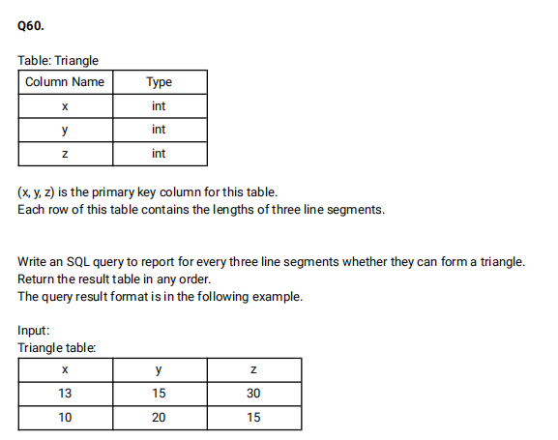

create table Triangle (

  x int,

  y int,

  z int,

  PRIMARY KEY (x,y,z)

 );

 INSERT INTO Triangle VALUES(13,15,30),(10,20,15);

 SELECT x,y,z,CASE

 when (x+y>z AND x+z>y AND y+z>x) then 'Yes'

 else 'No'

 end as triangle FROM Triangle;

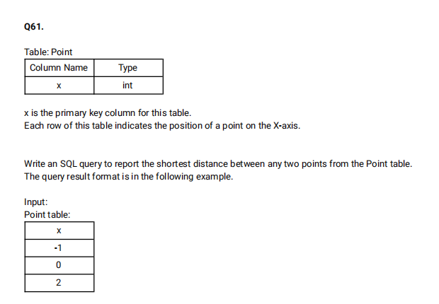

create table point (

  x INT PRIMARY KEY

 );

 insert INTO point VALUES(-1),(0),(2);

  select MIN(shortest) as shortest from (select  LEAD(a.x) OVER(order by a.x) -b.x as shortest from point a join point b on a.x=b.x)c;

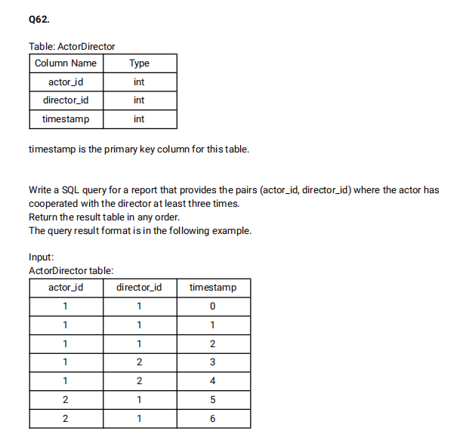

create Table Actordirector(

    actor_id int,

    director_id int,

    timestamp int PRIMARY KEY

  );

  INSERT INTO Actordirector VALUES (1,1,0),(1,1,1),(1,1,2),(1,2,3),(1,2,4),(2,1,5),(2,1,6);

  select actor_id,director_id from (select actor_id,director_id,COUNT(timestamp) as cnt from Actordirector group by actor_id,director_id) a where cnt >=3;

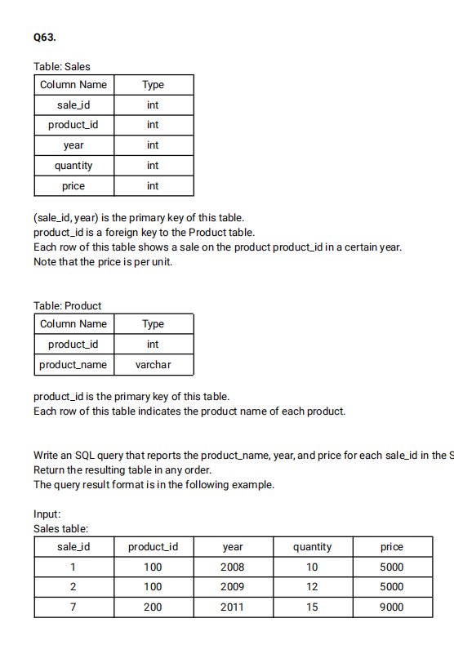

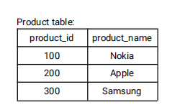

create table Sales (

    sale_id int,

    product_id int,

    year int,

    quantity int,

    price int,

    PRIMARY KEY(sale_id,year)

  );

  create Table product(

    product_id int PRIMARY KEY,

    product_name VARCHAR(50)

  );

  INSERT INTO Sales VALUES(1,100,2008,10,5000),(2,100,2009,12,5000),(7,200,2011,15,9000);

  INSERT INTO product VALUES(100,'Nokia'),(200,'Apple'),(300,'Samsung');

  select product_name,year,price from Sales s join product p on s.product_id=p.product_id;

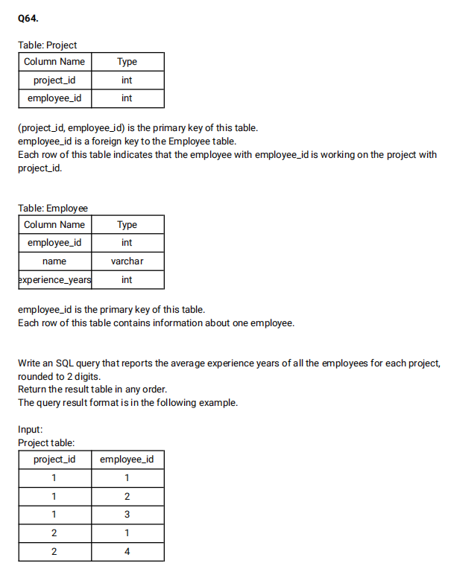

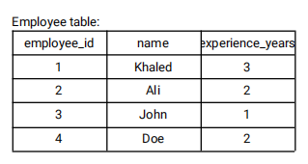

create table project(

    project_id INT,

    employee_id INT,

    PRIMARY KEY (project_id,employee_id)

  );

  create table Employee(

    employee_id int PRIMARY KEY,

    employee_name varchar(50),

    experience_years INT

  );

  INSERT into project VALUES (1,1),(1,2),(1,3),(2,1),(2,4);

  INSERT INTO Employee VALUES (1,'Khaled',3),(2,'Ali',2),(3,'John',1),(4,'Doe',2);

  select project_id,Round(AVG(experience_years),2) as average_years from Employee e join project p on e.employee_id=p.employee_id group by project_id;

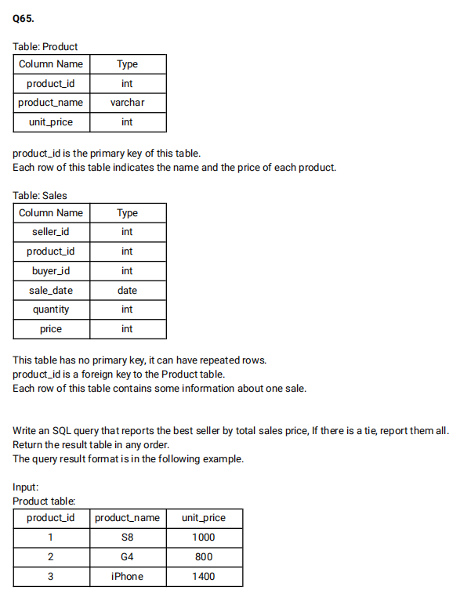

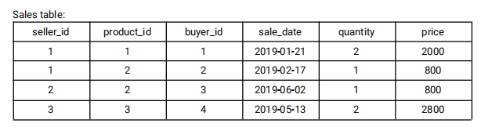

create table product (

    product_id INT,

    product_name VARCHAR(50),

    unit_price INT

  );

 ALTER table product  ADD CONSTRAINT  PRIMARY KEY(product_id);

  create table sales(

    seller_id INT,

    product_id INT,

    buyer_id INT,

    sale_date DATE,

    quantity INT,

    price INT,

    Foreign Key (product_id) REFERENCES product(product_id)

  );

  INSERT INTO product VALUES(1,'S8',1000),(2,'G4',800),(3,'iphone',1400);

  INSERT INTO sales VALUES(1,1,1,'2019-01-21',2,2000),(1,2,2,'2019-02-17',1,800),(2,2,3,'2019-06-02',1,800),(3,3,4,'2019-05-13',2,2800);

  select seller_id from (select seller_id,sum,RANK() over( order by sum desc) as rnk from (select seller_id, SUM(price) as sum from sales s join product p on s.product_id=p.product_id group by seller_id)a)b where rnk=1 ;

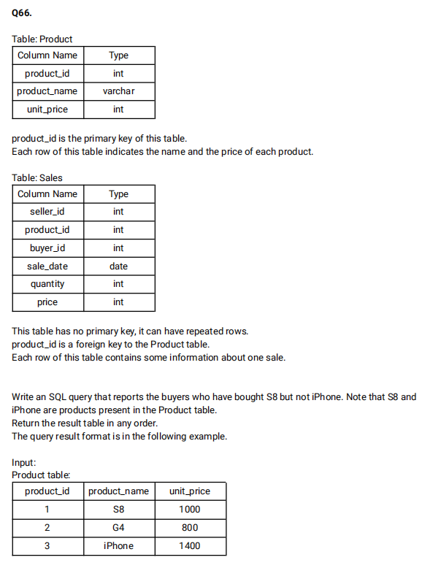

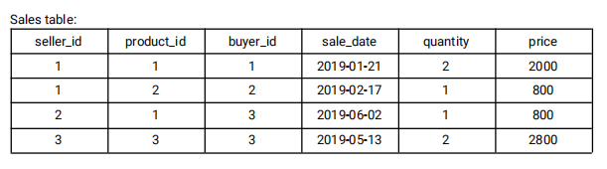

select buyer_id from sales s join product p on s.product_id=p.product_id where p.product_name ='S8' AND p.product_name <> 'iphone';

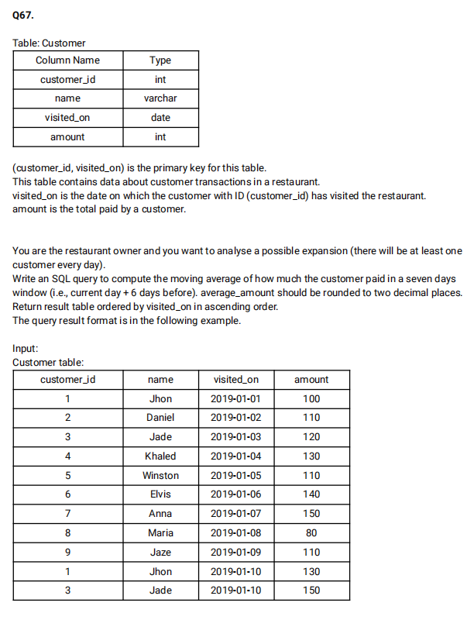

create table customer (

    customer_id INT,

    name varchar(50),

    visited_on DATE,

    amount INT

  );

  ALTER table customer ADD constraint PRIMARY KEY(customer_id,visited_on);

  insert into customer VALUES (1,'John','2019-01-01',100),(2,'Daniel','2019-01-02',110),(3,'Jade','2019-01-03',120),(4,'Khaled','2019-01-04',130),(5,'Winston','2019-01-05',110),(6,'Elvis','2019-01-06',140),(7,'Anna','2019-01-07',150),(8,'Maria','2019-01-08',80),(9,'Jaze','2019-01-09',110),(1,'John','2019-01-10',130),(3,'Jade','2019-01-10',150);

 select c1.visited_on, SUM(c1.amount) as amount, round(AVG(c2.amount),2) as average_amount from (select visited_on,sum(amount) as amount from customer group by visited_on)c1 join (select visited_on,sum(amount) as amount from customer group by visited_on)c2 on DATEDIFF(c1.visited_on,c2.visited_on) between 0 and 6 group by c1.visited_on having count(c2.amount)=7 order by c1.visited_on;

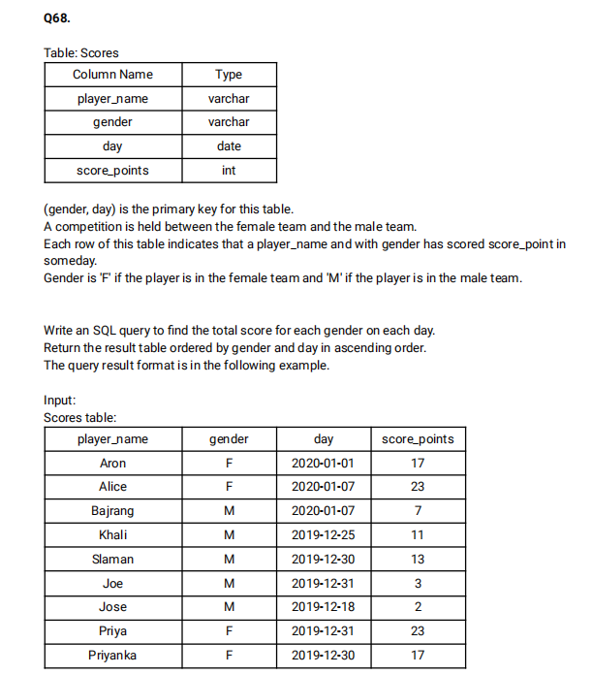

create table Scores (

  player_name varchar(100),

  gender varchar(10),

  day date,

  score_points int,

  PRIMARY KEY(gender,day)

 );

 INSERT INTO Scores VALUES('Aron','F','2020-01-01',17),('Alice','F','2020-01-07',23),('Bajrang','M','2020-01-07',7),('Khali','M','2019-12-25',11),('Slaman','M','2019-12-30',13),('Joe','M','2019-12-31',3),('Jose','M','2019-12-18',2),('Priya','F','2019-12-31',23),('Priyanka','F','2019-12-30',17)

 select gender,day,SUM(score_points) over(partition by gender order by gender,day) as total from Scores;

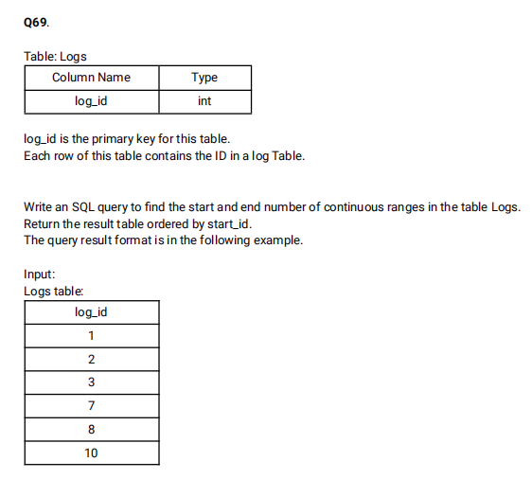

create table Logs (

  log_id int PRIMARY KEY

 );

 INSERT INTO Logs VALUES (1),(2),(3),(7),(8),(10);

 select min(log_id) as start_id,max(log_id) as end_id from (select log_id,rn,log_id-rn as diff from (select log_id, ROW_NUMBER() OVER() as rn from Logs)l1)l2 GROUP BY diff;

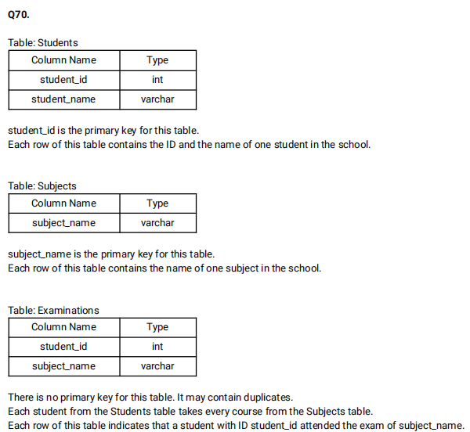

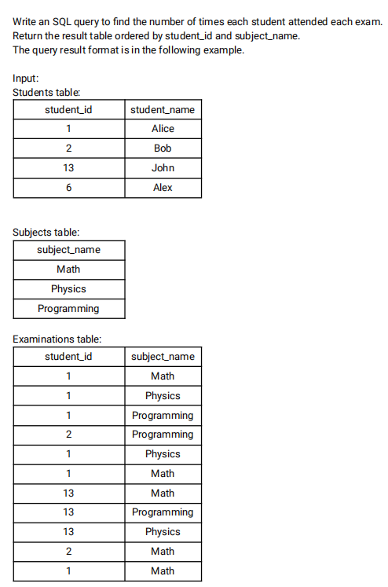

create table examinations(

  student_id INT,

  subject_name varchar(20)

 );

 create table subjects(

  subject_name varchar(20) PRIMARY KEY

 );

 ALTER Table examinations RENAME COLUMN subject_name to student_name;

 ALTER Table examinations RENAME COLUMN student_name to subject_name;

 create table students(

  student_id INT primary KEY,

  student_name varchar(25)

 );

 INSERT INTO students VALUES (1,'Alice'),(2,'Bob'),(13,'John'),(6,'Alex');

 INSERT INTO subjects VALUES('Math'),('Physics'),('Programming');

 INSERT INTO examinations VALUES (1,'Math'),(1,'Physics'),(1,'Programming'),(2,'Programming'),(1,'Physics'),(1,'Math'),(13,'Math'),(13,'Programming'),(13,'Physics'),(2,'Math'),(1,'Math');

 select s.student_id,student_name,s1.subject_name,count(e.student_id) as attended_exams from students s join subjects s1 left join examinations e on e.student_id=s.student_id and s1.subject_name=e.subject_name GROUP BY s.student_id,student_name,subject_name order by s.student_id,subject_name;

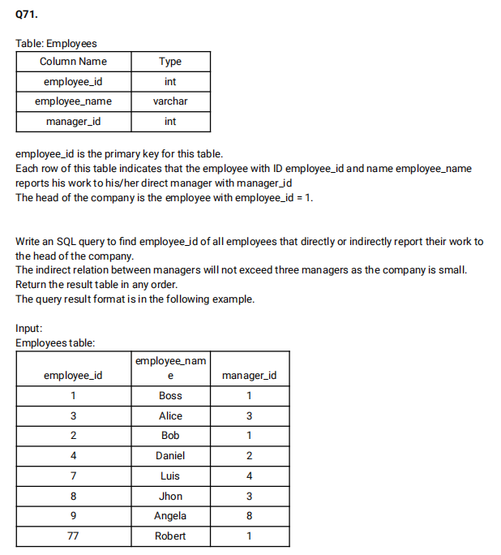

create table Employees(

  employee_id INT PRIMARY KEY,

  employee_name VARCHAR(50),

  manager_id INT

 );

 INSERT INTO Employees VALUES (1,'Boss',1),(3,'Alice',3),(2,'Bob',1),(4,'Daniel',2),(7,'Luis',4),(8,'John',3),(9,'Angela',8),(77,'Robert',1);

 select e4.emp_id  FROM

((select e2.employee_id as e_id,e1.manager_id as m_id from Employees e1 join Employees e2 where e2.manager_id=e1.employee_id and e2.employee_id <>1)e3

  RIGHT join

(select e2.employee_id as emp_id,e1.manager_id as mng_id from Employees e1 join Employees e2 where e2.manager_id=e1.employee_id and e2.employee_id <>1)e4

 ON e4.mng_id=e3.e_id) where m_id is null or m_id=1;

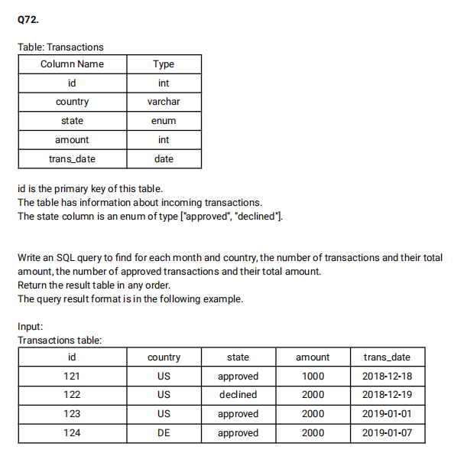

create table Transactions(

  id INT PRIMARY KEY,

  country VARCHAR(20),

  state ENUM('approved','declined'),

  amount INT,

  trans_date date

);

INSERT INTO Transactions VALUES(121,"US",'approved',1000,'2018-12-18');

INSERT INTO Transactions VALUES(122,"US",'declined',2000,'2018-12-19'),(123,"US",'approved',2000,'2019-01-01'),(124,"DE",'approved',2000,'2019-01-07');

select EXTRACT(YEAR_MONTH from trans_date) as month,country,count(amount) as trans_count,sum(case when state='approved' then 1 else 0 end) as approved_count,sum(amount) as trans_total_amount, sum(case when state='approved' then amount else 0 end)as approved_amount from Transactions GROUP BY month,country

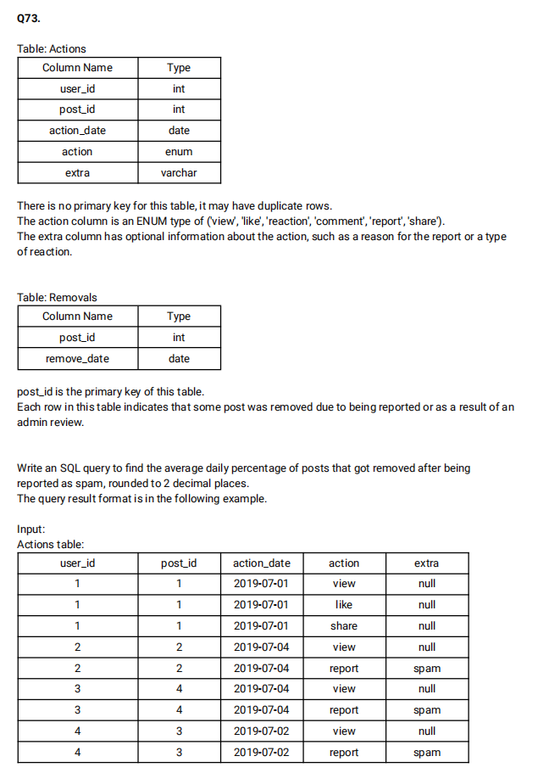

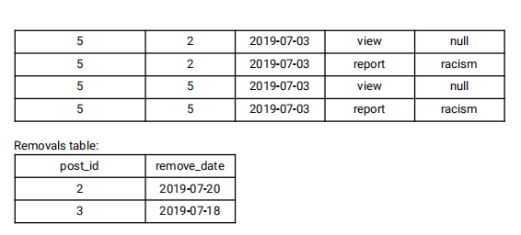

create table Actions(

  user_id int,

  post_id int,

  action_date date,

  action enum('view','like','reaction','comment','report','share'),

  extra varchar(10)

  );

  create table removals(

    post_id INT PRIMARY KEY,

    remove_date date

  );

  INSERT INTO Actions VALUES(1,1,'2019-07-01','view',NULL),(1,1,'2019-07-01','like',NULL),(1,1,'2019-07-01','share',NULL),(2,2,'2019-07-04','view',NULL),(2,2,'2019-07-04','report','spam'),(3,4,'2019-07-04','view',NULL),(3,4,'2019-07-04','report','spam'),(4,3,'2019-07-02','view',NULL),(4,3,'2019-07-02','report','spam');

  insert into Actions VALUES(5,2,'2019-07-03','view',NULL),(5,2,'2019-07-03','report','racism'),(5,5,'2019-07-03','view',NULL),(5,5,'2019-07-03','report','racism');

  INSERT INTO removals VALUES(2,'2019-07-20'),(3,'2019-07-18');

select ROUND(AVG(cnt1),2) as avg_daily_percent from (select (count(b.post_id)*100)/(count(a.post_id)) as cnt1 from Actions a left join removals b on a.post_id=b.post_id where extra='spam' group by action_date)c;

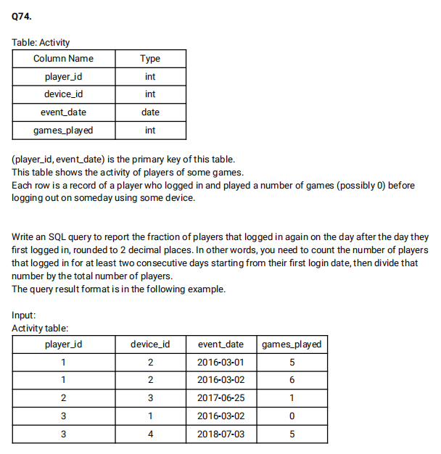

create table Activity(

  player_id INT,

  device_id INT,

  event_date date,

  games_played INT,

  PRIMARY KEY(player_id,event_date)

);

INSERT INTO Activity VALUES(1,2,'2016-03-01',5),(1,2,'2016-03-02',6),(2,3,'2017-06-25',1),(3,1,'2016-03-02',0),(3,4,'2018-07-03',5);

select ROUND(count(distinct b.player_id)/count(distinct a.player_id),2) as fraction from Activity a left join Activity b on b.player_id=a.player_id and a.device_id=b.device_id and DATEDIFF(a.event_date,b.event_date)<>0

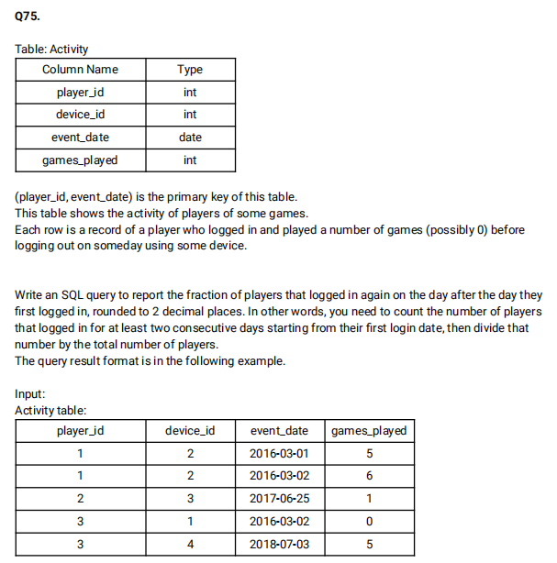

create table Activity(

  player_id INT,

  device_id INT,

  event_date date,

  games_played INT,

  PRIMARY KEY(player_id,event_date)

);

INSERT INTO Activity VALUES(1,2,'2016-03-01',5),(1,2,'2016-03-02',6),(2,3,'2017-06-25',1),(3,1,'2016-03-02',0),(3,4,'2018-07-03',5);

select ROUND(count(distinct b.player_id)/count(distinct a.player_id),2) as fraction from Activity a left join Activity b on b.player_id=a.player_id and a.device_id=b.device_id and DATEDIFF(a.event_date,b.event_date)<>0;

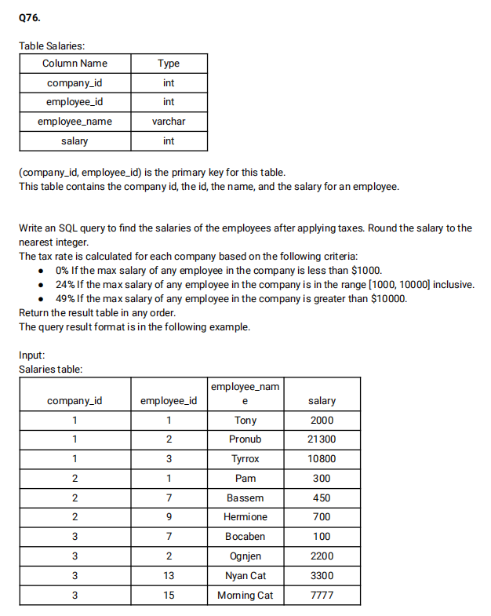

create table salaries(

  company_id INT,

  employee_id INT,

  employee_name varchar(25),

  salary INT,

  PRIMARY KEY (company_id,employee_id)

);

INSERT INTO salaries VALUES(1,1,'Tony',2000),(1,2,'Pronub',21300),(1,3,'Tyrrox',10800),(2,1,'Pam',300),(2,7,'Bassem',450),(2,9,'Hermione',700),(3,7,'Bocaben',100),(3,2,'Ognjen',2200),(3,13,'Nyan Cat',3300),(3,15,'Morning cat',7777);

select s1.company_id,s1.employee_id,s1.employee_name, ROUND(CASE when s2.max_salary BETWEEN 1000 AND 10000 then 0.76*salary

                                                  when s2.max_salary>10000 then 0.51*salary

                                                  else salary end) as salary from salaries s1 join (select company_id,MAX(salary) as max_salary from salaries s2 group by company_id)s2 on s1.company_id=s2.company_id order by company_id;

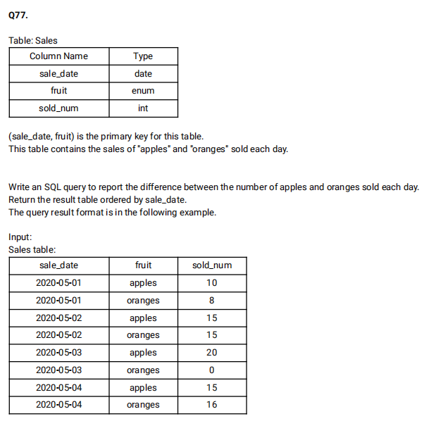

create table Sales(

  sale_date date,

  fruit ENUM('apples','oranges'),

  sold_num int,

  primary KEY(sale_date,fruit)

);

INSERT INTO Sales VALUES('2020-05-01','apples',10),('2020-05-01','oranges',8),('2020-05-02','apples',15),('2020-05-02','oranges',15),('2020-05-03','apples',20),('2020-05-03','oranges',0),('2020-05-04','apples',15),('2020-05-04','oranges',16);

select sale_date ,(sum(case when fruit='apples' then sold_num else 0 end) - sum(case when fruit='oranges' then sold_num else 0 end)) as diff from Sales GROUP BY sale_date;

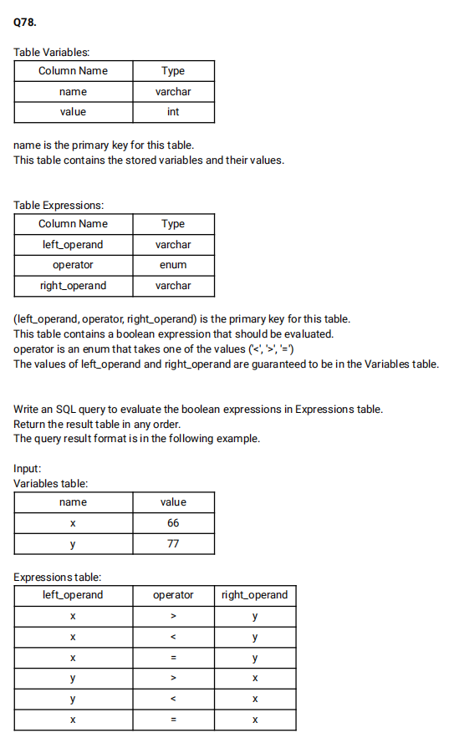

create table Variables (

  name varchar(50),

  value INT,

  PRIMARY KEY(name)

);

create table Expressions(

  left_operand varchar(2),

  operator ENUM('<','>','='),

  right_operand VARCHAR(2),

  PRIMARY KEY(left_operand,operator,right_operand)

);

insert INTO Variables VALUES('x',66),('y',77);

INSERT INTO Expressions VALUES('x','>','y'),('x','<','y'),('x','=','y'),('y','>','x'),('y','<','x'),('x','=','x');

select left_operand,operator,right_operand,

(case when operator='<' then if(v1.value<v2.value,'true','false')

when operator='>' then if(v1.value>v2.value,'true','false')

else if(v1.value=v2.value,'true','false') end) as value from Expressions e left join Variables v1 on e.left_operand=v1.name

left join Variables v2 on e.right_operand=v2.name;

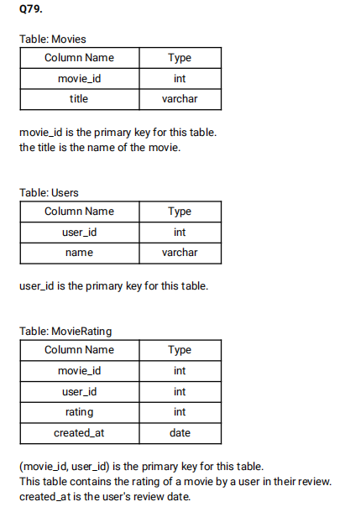

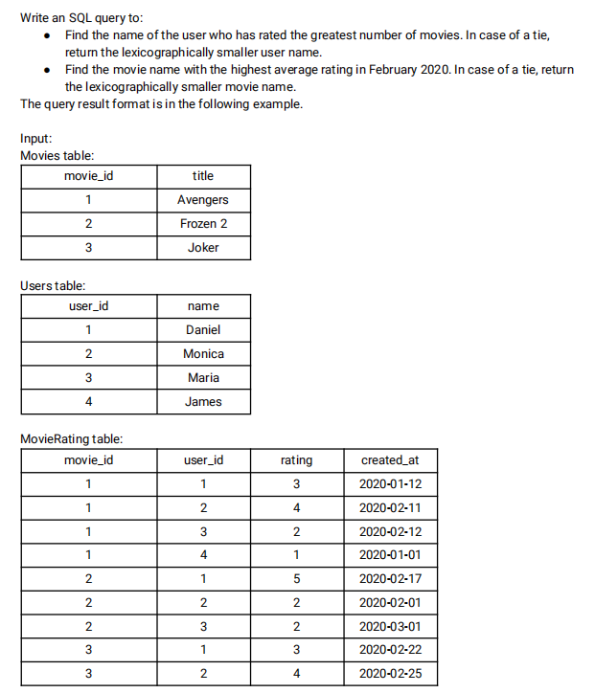

create table movies (

  movie_id INT PRIMARY KEY,

  title VARCHAR(20)

);

create table Users(

  user_id INT PRIMARY KEY,

  name VARCHAR(50)

);

create table movierating(

  movie_id INT,

  user_id INT,

  rating INT,

  created_at DATE,

  PRIMARY KEY(movie_id,user_id)

);

INSERT INTO movies VALUES(1,'Avengers'),(2,'Frozen2'),(3,'Joker');

INSERT INTO Users VALUES(1,'Daniel'),(2,'Monica'),(3,'Maria'),(4,'James');

INSERT INTO movierating VALUES(1,1,3,'2020-01-12'),(1,2,4,'2020-02-11'),(1,3,2,'2020-02-12'),(1,4,1,'2020-01-01'),(2,1,5,'2020-02-17'),(2,2,2,'2020-02-01'),(2,3,2,'2020-03-01'),(3,1,3,'2020-02-22'),(3,2,4,'2020-02-25');

select a.name as results from (select u.name,count(mr.rating) as cnt from Users u join movierating mr on mr.user_id=u.user_id group by u.name order by cnt desc,u.name limit 1)a

union ALL

select b.title as results from (select title,AVG(mr.rating) as avg from movies m join movierating mr on mr.movie_id=m.movie_id where Extract(YEAR_MONTH from created_at)='202002' group by title order by avg desc,title limit 1)b;

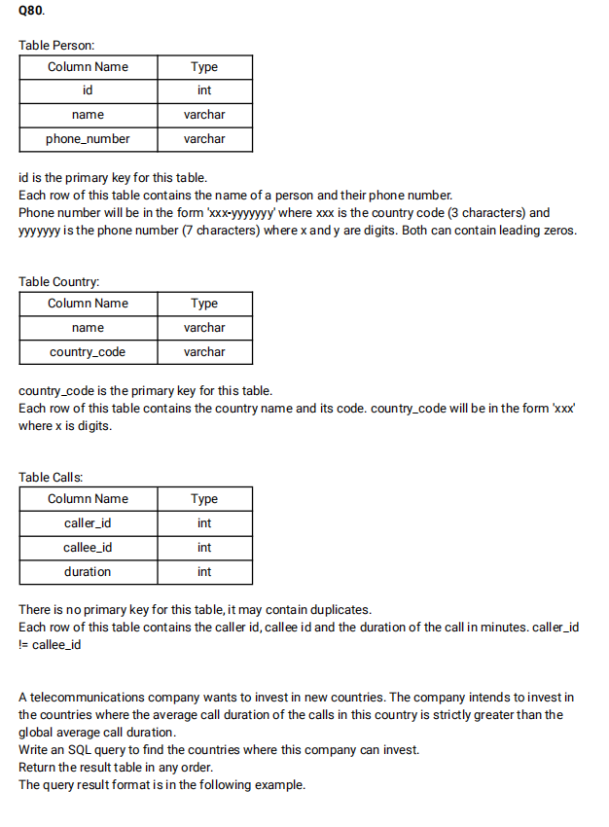

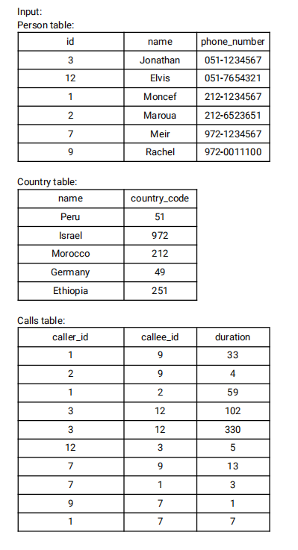

create table person(

    id INT,

    name VARCHAR(255),

    phone_number VARCHAR(255)

 );

 create table country(

    name VARCHAR(50),

    country_code VARCHAR(10) PRIMARY KEY

 );

 ALTER Table person ADD constraint PRIMARY KEY(id);

 create table calls(

    caller_id INT,

    callee_id INT,

    duration INT

 );

 INSERT INTO person VALUES(3,'Jonathan','051-1234567'),(12,'Elvis','051-7654321'),(1,'Moncef','212-1234567'),(2,'Maroua','212-6523651'),(7,'Meir','972-1234567'),(9,'Rachel','972-0011100');

 INSERT INTO country VALUES ('Peru','051'),('Israel','972'),('Morocco','212'),('Germany','49'),('Ethiopia','251');

 INSERT INTO calls VALUES (1,9,33),(2,9,4),(1,2,59),(3,12,102),(3,12,330),(12,3,5),(7,9,13),(7,1,3),(9,7,1),(1,7,7);

 select c.name as country from person p join country c on SUBSTRING(phone_number,1,3)=c.country_code join calls ca on p.id IN (ca.caller_id,ca.callee_id) group by c.name HAVING AVG(duration)>(select AVG(duration) from calls);

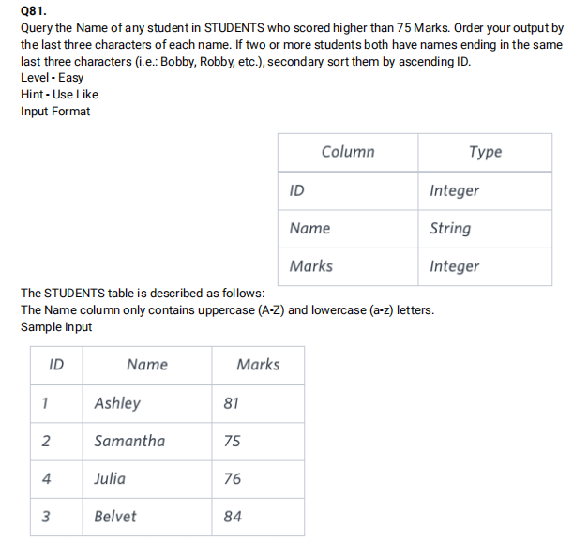

create Table Students(

  ID INT,

  Name VARCHAR(30),

  Marks INT

);

INSERT INTO Students VALUES(1,'Ashley',81),(2,'Samantha',75),(4,'Julia',76),(3,'Belvet',84);

select name from Students where marks>75 order by right(name,3),id;

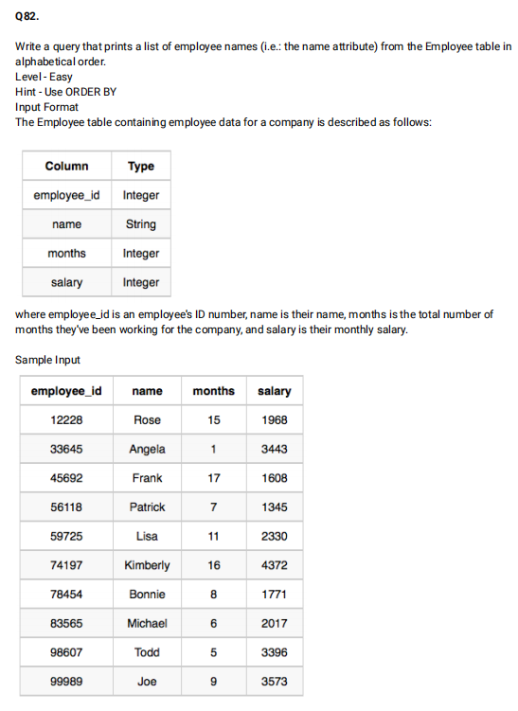

create table Employees(

  employee_id INT,

  name VARCHAR(30),

  months INT,

  salary INT

);

INSERT INTO Employees VALUES(12228,'Rose',15,1968),(33645,'Angela',1,3443),(45692,'Frank',17,1608),(56118,'Pattrick',7,1345),(59725,'Lisa',11,2330),(74197,'Kimberly',16,4372),(78454,'Bonnie',8,1771),(83565,'Michael',6,2017),(98607,'Todd',5,3396),(99989,'Joe',9,3573);

select name from Employees order by name;

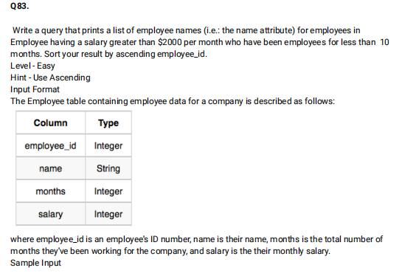

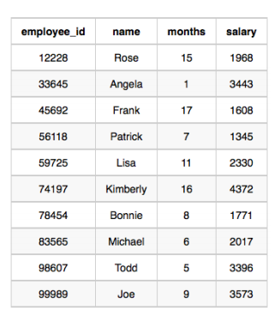

create table Employees(

  employee_id INT,

  name VARCHAR(30),

  months INT,

  salary INT

);

INSERT INTO Employees VALUES(12228,'Rose',15,1968),(33645,'Angela',1,3443),(45692,'Frank',17,1608),(56118,'Pattrick',7,1345),(59725,'Lisa',11,2330),(74197,'Kimberly',16,4372),(78454,'Bonnie',8,1771),(83565,'Michael',6,2017),(98607,'Todd',5,3396),(99989,'Joe',9,3573);

select name from Employees where months<10 and salary >2000;



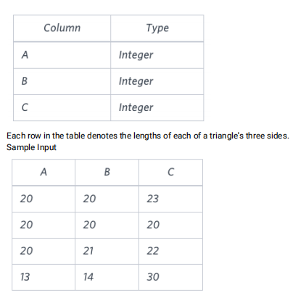

create table Triangle(

  A int,

  B INT,

  C INT

);

INSERT INTO Triangle VALUES(20,20,23),(20,20,20),(20,21,22),(13,14,30);

select IF((A+B<C or B+C<A or A+C<B),'Not a Triangle',(case when A=B=C then 'Equilateral' when A<>B and B<>C then 'Scalene' else 'Isoceles' end)) as Type from Triangle;

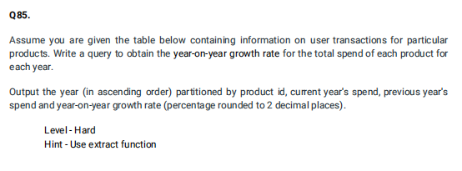

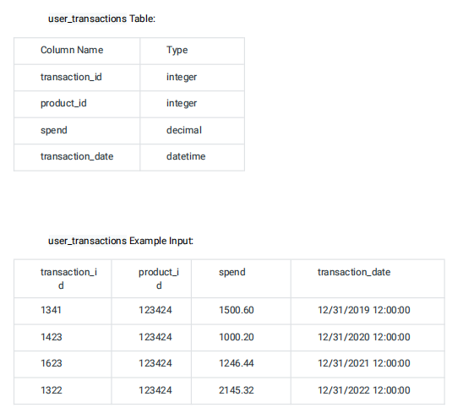

create table user_transactions(

  transaction_id INT,

  product_id INT,

  spend DECIMAL(6,2),

  transaction_date datetime

);

INSERT INTO user_transactions VALUES(1341,123424,1500.60,'2019-12-31 12:00:00');

INSERT INTO user_transactions VALUES(1423,123424,1000.20,'2020-12-31 12:00:00'),(1623,123424,1246.44,'2021-12-31 12:00:00'),(1322,123424,2145.32,'2022-12-31 12:00:00');

select year,curr_year_spend,prev_year_spend,ROUND((((curr_year_spend-prev_year_spend)*100)/prev_year_spend),2) as yoy_rate from (select Extract(year from transaction_date) as year,spend as curr_year_spend,lag(spend) over(order by EXTRACT(year from transaction_date)) as prev_year_spend from user_transactions order by year)a;

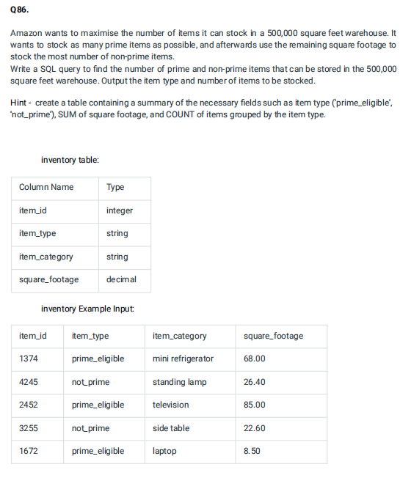

create table Inventory(

  item_id INT,

  item_type VARCHAR(20),

  item_category VARCHAR(20),

  square_footage DECIMAL(6,2)

);

INSERT INTO Inventory VALUES(1374,'prime eligible','mini refrigerator',68.00);

INSERT into Inventory VALUES(4245,'not prime','standing lamp',26.40),(2452,'prime eligible','television',85.00),(3255,'not prime','side table',22.60),(1672,'prime eligible','laptop',8.50);

select item_type,count(item_id) as item_count from Inventory where square_footage<500000 GROUP BY item_type;

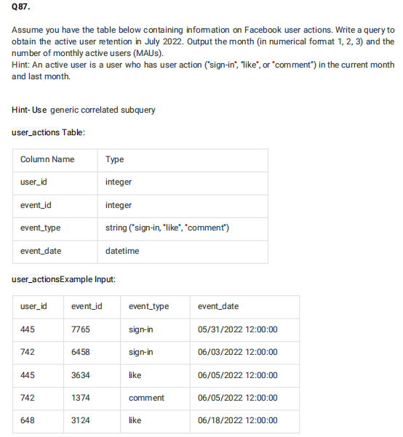

create table user_actions(

  user_id INT,

  event_id INT,

  event_type ENUM('like','comment','sign-in'),

  event_date DATETIME

);

INSERT INTO user_actions VALUES(445,7765,'sign-in','2022-05-31 12:00:00'),(742,6458,'sign-in','2022-06-03 12:00:00'),(445,3634,'like','2022-06-05 12:00:00'),(742,1374,'comment','2022-06-05 12:00:00'),(648,3124,'like','2022-06-18 12:00:00');

select EXTRACT(MONTH from event_date) as month,sum(case when event_type='like' or event_type='comment' or event_type='sign-in' then 1 else 0 end) as monthly_active_users from user_actions group by month;

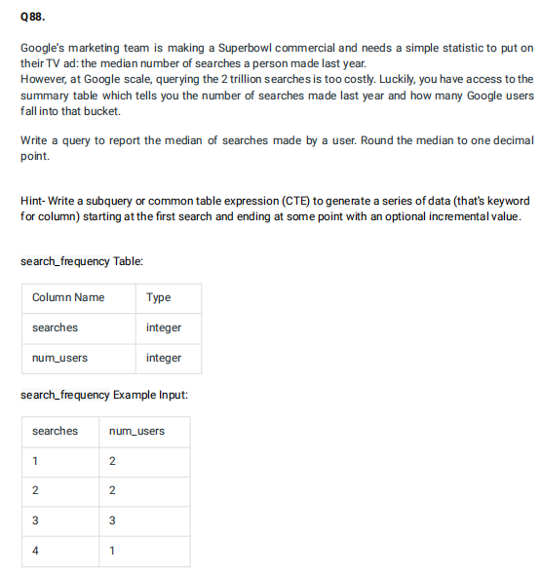

create table search_frequency (

  searches INT,

  num_users INT

);

DELETE from search_frequency where searches=1 or searches=2 or searches=3 or searches=4;

INSERT INTO search_frequency VALUES (1,2),(2,2),(3,3),(4,1);

alter table search_frequency modify column searches INTEGER;

select AVG(searches) from (select searches, ROW_NUMBER() OVER(order by searches) as rn_asc,ROW_NUMBER() OVER(order by searches desc) rn_desc from search_frequency order by searches)a where ABS(rn_asc-rn_desc)<=1;

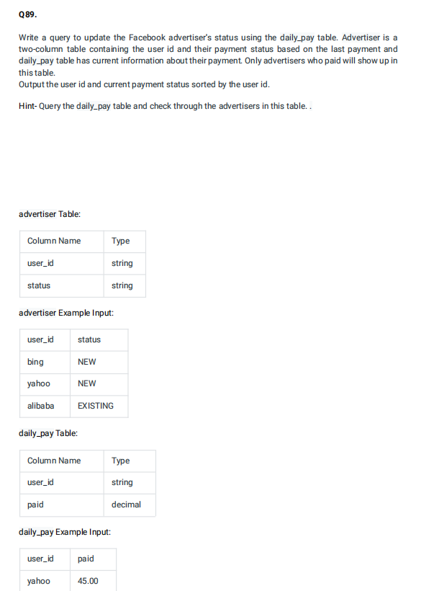

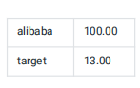

create table advertiser (

  user_id VARCHAR(10),

  status VARCHAR(15)

);

create table daily_pay(

  user_id VARCHAR(10),

  paid DECIMAL(6,2)

);

INSERT INTO advertiser VALUES('bing','New'),('yahoo','New'),('alibaba','existing');

INSERT INTO daily_pay VALUES('yahoo',45.00),('alibaba',100.00),('target',13.00);

WITH pay_status as

 ((select a.user_id, a.status ,paid from advertiser a left join daily_pay d on d.user_id=a.user_id)

UNION

(select d.user_id,a.status,paid from daily_pay d left join advertiser a on d.user_id=a.user_id))

select user_id, (case when paid is NULL then 'Churn'

when STATUS ='Churn' and paid is not NULL then 'Resurrect'

when STATUS <> 'Churn' and paid is NOT NULL then 'Existing'

when STATUS is NULL then 'NEW' end) as new_status

FROM pay_status;

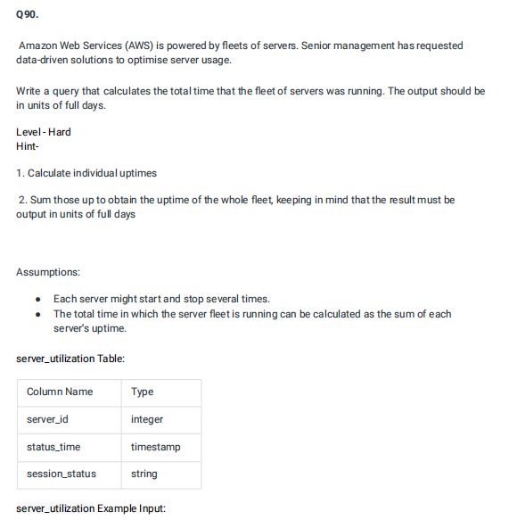

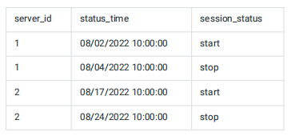

create table server_utilization(

  server_id INT,

  status_time TIMESTAMP,

  session_status VARCHAR(20)

);

INSERT INTO server_utilization VALUES(1,'2022-08-02 10:00:00','start'),(1,'2022-08-04 10:00:00','stop'),(2,'2022-08-17 10:00:00','start'),(2,'2022-08-24','stop');

select sum(diff) as total_uptime_days from (select  s2.server_id,DATEDIFF(s2.status_time,s1.status_time) as diff from server_utilization s1 join server_utilization s2 on s2.server_id=s1.server_id where s2.session_status='stop')a;

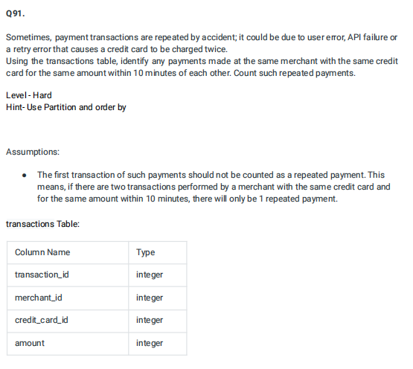

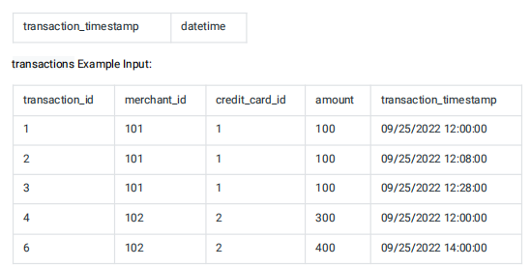

create table transactions (

  transaction_id INT,

  merchant_id INT,

  credit_card_id INT,

  amount INT,

  transaction_timestamp DATETIME

);

INSERT INTO transactions VALUES(1,101,1,100,'2022-09-25 12:00:00'),(2,101,1,100,'2022-09-25 12:08:00'),(3,101,1,100,'2022-09-25 12:28:00'),(4,101,1,300,'2022-09-25 12:00:00'),(6,102,2,400,'2022-09-25 14:00:00');

select count(distinct amount) as payment_count from (select  t2.transaction_id,t2.amount,TIMESTAMPDIFF(MINUTE,t2.transaction_timestamp,t1.transaction_timestamp) as t from transactions t1 join transactions t2 WHERE t1.transaction_id <> t2.transaction_id AND t1.merchant_id=t2.merchant_id AND t1.credit_card_id=t2.credit_card_id AND t1.amount=t2.amount)a where abs(t)<=10;

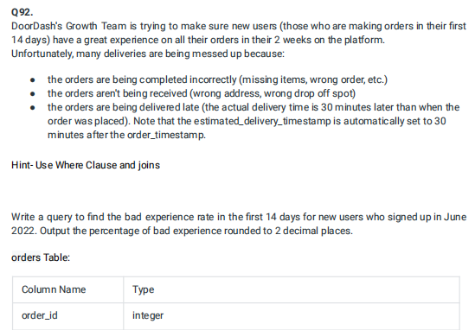

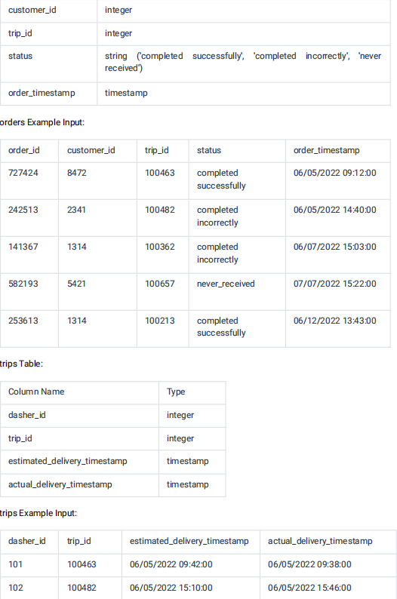

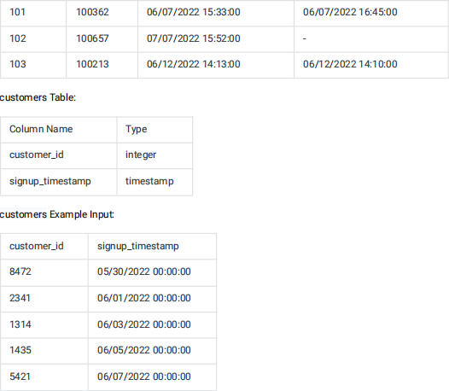

create table orders (

  order_id INT,

  customer_id INT,

  trip_id INT,

  status ENUM('completed successfully','completed incorrectly','never recieved'),

  order_timestamp timestamp

);

create table trips (

  dasher_id INT,

  trip_id INT,

  estimated_delivery_timestamp TIMESTAMP,

  actual_delivery_timestamp TIMESTAMP

);

create table customers (

  customer_id INT,

  signup_timestamp TIMESTAMP

);

INSERT INTO orders VALUES(727424,8472,100463,'completed successfully','2022-06-05 09:12:00'),(242513,2341,100482,'completed incorrectly','2022-06-05 14:40:00'),(141367,1314,100362,'completed incorrectly','2022-06-07 15:03:00'),(582193,5421,100657,'never recieved','2022-07-07 15:22:00'),(253613,1314,100213,'completed successfully','2022-06-12 13:43:00');

INSERT INTO trips VALUES(101,100463,'2022-06-05 09:42:00','2022-06-05 15:46:00'),(102,100482,'2022-06-05 15:10:00','2022-06-05 15:46:00'),(101,100362,'2022-06-07 15:33:00','2022-06-07 16:45:00'),(102,100657,'2022-07-07 15:52:00',NULL),(103,100213,'2022-06-12 14:13:00','2022-06-12 14:10:00');

INSERT INTO customers VALUES(8472,'2022-05-30 00:00:00'),(2341,'2022-06-01 00:00:00'),(1314,'2022-06-03 00:00:00'),(1435,'2022-06-05 00:00:00'),(5421,'2022-06-07 00:00:00');

select (((cnt-good_delivery)*100)/cnt) as bad_pct from (select COUNT(a.trip_id) as cnt,sum(case when a.status='completed successfully' AND TIMESTAMPDIFF(MINUTE,estimated_delivery_timestamp,actual_delivery_timestamp)>=0 then 1 else 0 end) as good_delivery from orders a left join trips b on b.trip_id=a.trip_id)a;

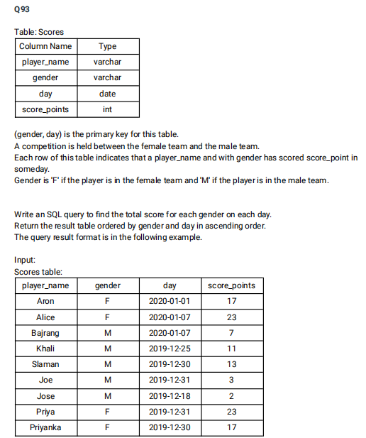

create table Scores (

  player_name varchar(100),

  gender varchar(10),

  day date,

  score_points int,

  PRIMARY KEY(gender,day)

 );

 INSERT INTO Scores VALUES('Aron','F','2020-01-01',17),('Alice','F','2020-01-07',23),('Bajrang','M','2020-01-07',7),('Khali','M','2019-12-25',11),('Slaman','M','2019-12-30',13),('Joe','M','2019-12-31',3),('Jose','M','2019-12-18',2),('Priya','F','2019-12-31',23),('Priyanka','F','2019-12-30',17)

 select gender,day,SUM(score_points) over(partition by gender order by gender,day) as total from Scores;

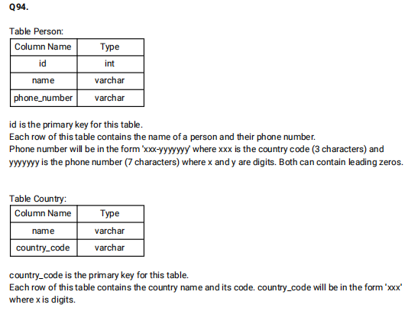

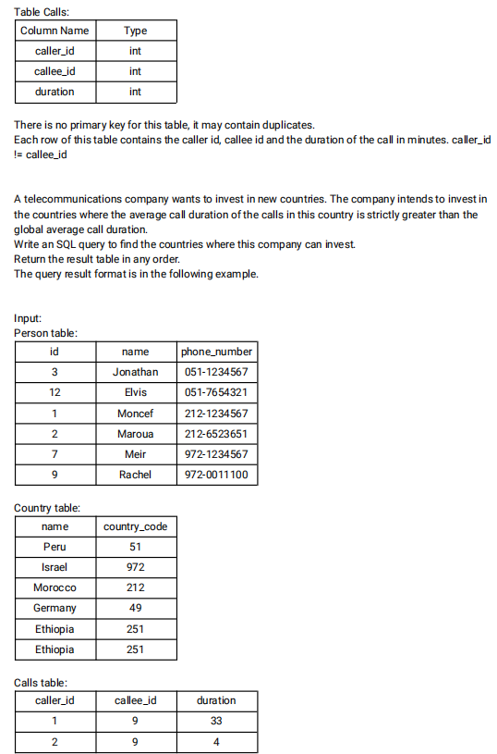

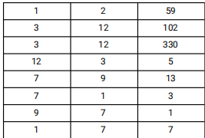

create table person(

    id INT,

    name VARCHAR(255),

    phone_number VARCHAR(255)

 );

 create table country(

    name VARCHAR(50),

    country_code VARCHAR(10) PRIMARY KEY

 );

 ALTER Table person ADD constraint PRIMARY KEY(id);

 create table calls(

    caller_id INT,

    callee_id INT,

    duration INT

 );

 INSERT INTO person VALUES(3,'Jonathan','051-1234567'),(12,'Elvis','051-7654321'),(1,'Moncef','212-1234567'),(2,'Maroua','212-6523651'),(7,'Meir','972-1234567'),(9,'Rachel','972-0011100');

 INSERT INTO country VALUES ('Peru','051'),('Israel','972'),('Morocco','212'),('Germany','49'),('Ethiopia','251');

 INSERT INTO calls VALUES (1,9,33),(2,9,4),(1,2,59),(3,12,102),(3,12,330),(12,3,5),(7,9,13),(7,1,3),(9,7,1),(1,7,7);

 select c.name as country from person p join country c on SUBSTRING(phone_number,1,3)=c.country_code join calls ca on p.id IN (ca.caller_id,ca.callee_id) group by c.name HAVING AVG(duration)>(select AVG(duration) from calls);

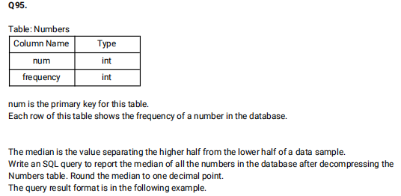

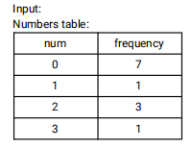

create table numbers(

  num INT,

  freq INT

);

INSERT INTO numbers VALUES(0,7),(1,1),(2,3),(3,1);

with cte as(

  select * from numbers

  union all

  select num, freq - 1

  from cte where freq > 1

), cte2 as(

  select *, rn = row_number() over(order by num), cn = count(1) over()

  from cte

)

select avg(num) from cte2

where rn between cn*1.0/2 and cn*1.0/2 + 1

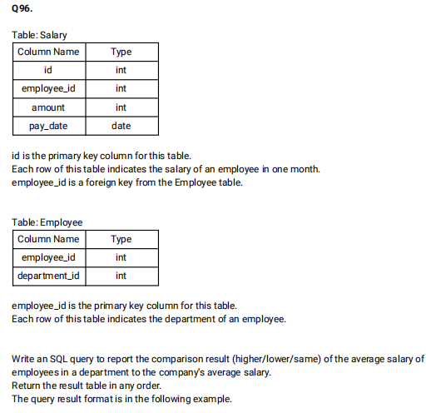

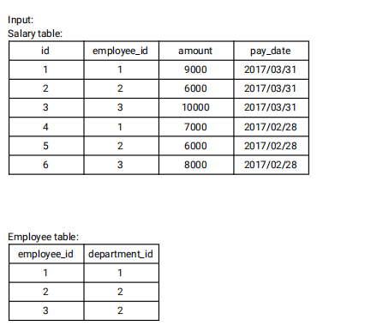

create Table Salary(

  id int,

  employee_id INT,

  amount INT,

  pay_date DATE

);

create table Employee(

  employee_id INT,

  department_id INT

);

INSERT INTO Salary VALUES(1,1,9000,'2017-03-31'),(2,2,6000,'2017-03-31'),(3,3,10000,'2017-03-31'),(4,1,7000,'2017-02-28'),(5,2,6000,'2017-02-28'),(6,3,8000,'2017-02-28');

INSERT INTO Employee VALUES(1,1),(2,2),(3,2);

select dept_salary.pay_month,dept_salary.department_id,(case when dept_avg>comp_avg then 'Higher' when dept_avg<comp_avg then 'Lower' else 'Same' end) as comparison  from ((select e.department_id,EXTRACT(YEAR_MONTH from pay_date) as pay_month,AVG(amount) as dept_avg from Salary s join Employee e on e.employee_id=s.employee_id group by e.department_id,pay_month) as dept_salary join

(select AVG(amount) as comp_avg,EXTRACT(year_month from pay_date) as pay_month from Salary GROUP BY pay_month) as comp_salary on dept_salary.pay_month=comp_salary.pay_month) order by dept_salary.department_id;

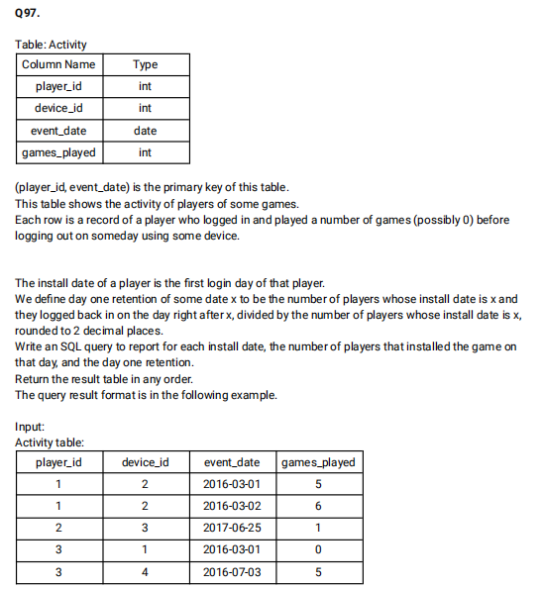

select a.install_date,count(a.install_date) as installs,ROUND(count(b.event_date)/count(*),2) from (select player_id,min(event_date) as install_date from Activity GROUP BY player_id)a left join Activity b on DATE_ADD(a.install_date, INTERVAL 1 DAY)=b.event_date AND a.player_id=b.player_id group by a.install_date order by a.install_date;

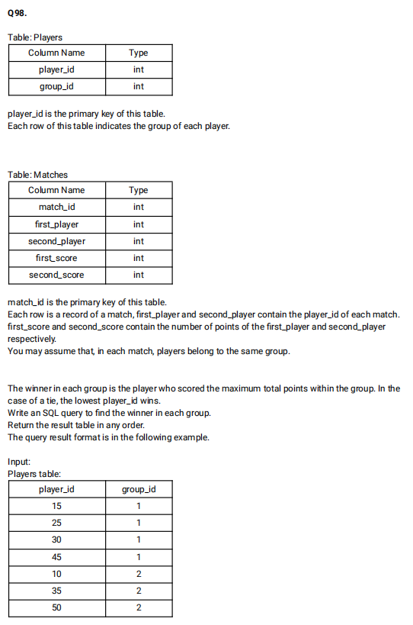

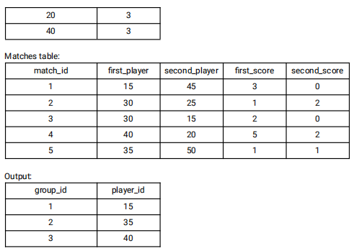

SELECT group_id,player_id

FROM   (SELECT p.group_id,ps.player_id,  Sum(ps.score) AS score   FROM players p INNER JOIN (SELECT first_player AS player_id,  first_score  AS score  FROM   matches

  UNION ALL

  SELECT second_player AS player_id, second_score  AS score FROM   matches) ps  ON  p.player_id = ps.player_id   GROUP  BY ps.player_id  ORDER  BY group_id, score DESC, player_id) top_scores

GROUP  BY group_id;

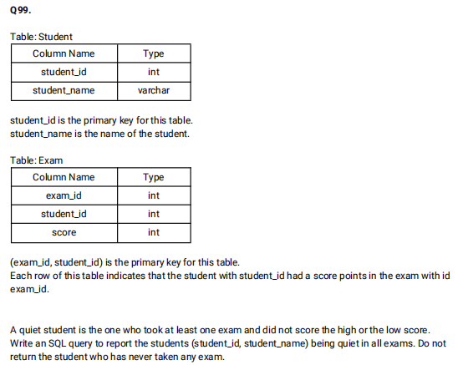

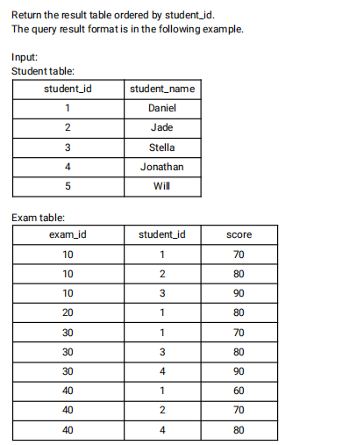

select distinct s.student_id,s.student_name

from Student s inner join Exam e

on s.student_id = e.student_id

where s.student_id not in (select e1.student_id from Exam as e1 inner join (select exam_id, min(score) as min_score, max(score) as max_score from Exam group by exam_id) as e2 on e1.exam_id = e2.exam_id where e1.score = e2.min_score or e1.score = e2.max_score) order by student_id;

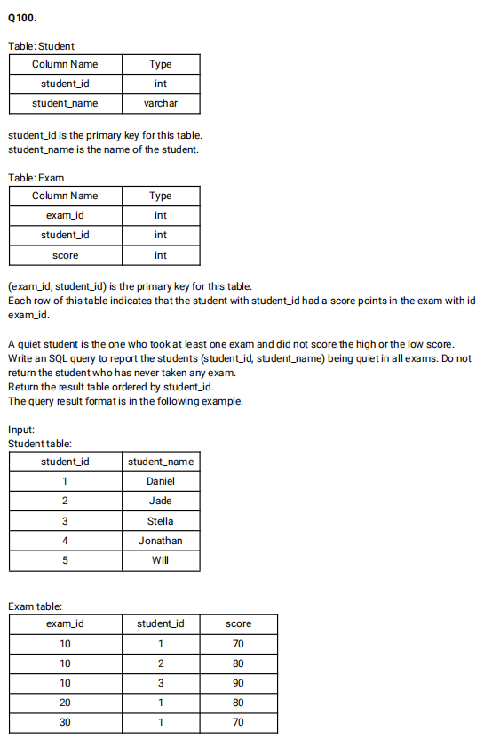

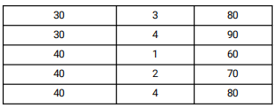

select distinct s.student_id,s.student_name

from Student s inner join Exam e

on s.student_id = e.student_id

where s.student_id not in (select e1.student_id from Exam as e1 inner join (select exam_id, min(score) as min_score, max(score) as max_score from Exam group by exam_id) as e2 on e1.exam_id = e2.exam_id where e1.score = e2.min_score or e1.score = e2.max_score) order by student_id;